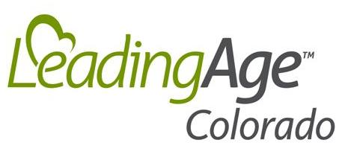
18475 W. Colfax Ave
Ste 132 PMB1011
Golden, CO 80401
P: (303) 837-8834

LeadingAge Colorado 2025 Business Membership Investment Invoice

Business Name: ____

Address: ____

City, State, Zip: ____

Phone: Fax: ____

Contact Person: Title: ____

Email: ____

Voting Member (if different from Contact Person): __________________________________________________________

Products or Services: ____

Website Address: ____

Home Office (if different): ____

Home Office Address: ____

Home Office City, State, Zip: ____

Dues Options (Choose only one from list):

$1,200 Standard Business Membership

$600 Affiliate member (non-voting, affiliate membership – available only to educational institutions, government agencies & professional associations)

TOTAL DUES REMITTANCE: $

Return this original invoice to LeadingAge Colorado with your payment.

Mail to: LeadingAge Colorado
18475 W. Colfax Ave
Ste 132 PMB1011
Golden, CO 80401

Or Register Online at: https://www.leadingagecolorado.org/business-membership

LeadingAge Colorado (LAC) dues are not deductible as a charitable contribution for federal income tax purposes but may be partially deducted as a business expense. LAC estimates that 8.4% of your state membership dues are allocable to lobbying activities of LAC, and therefore are not deductible for income tax purposes.

